**Steps to create Function Group**

1. Go to t code se80

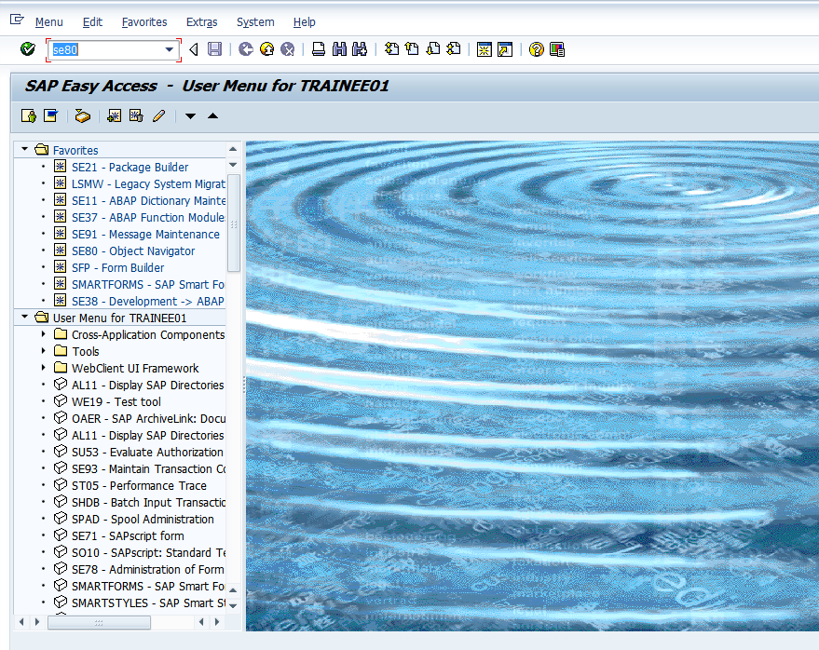

1. Choose Function Group in the object category

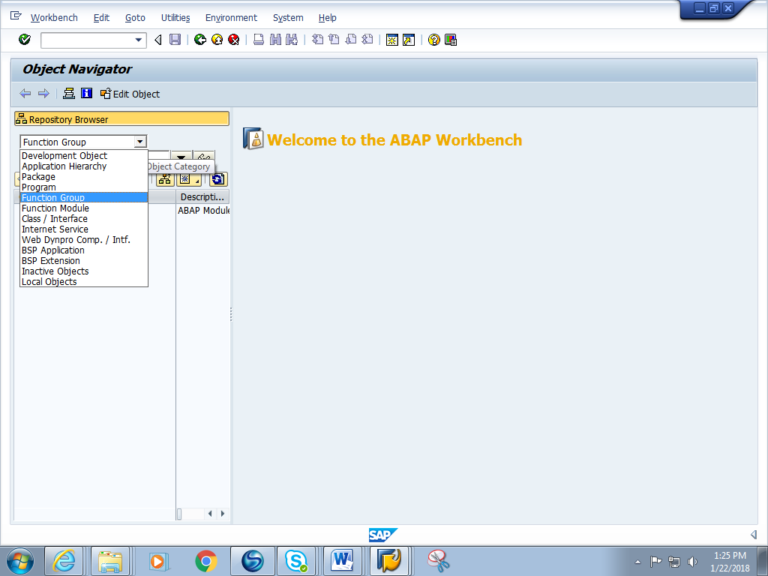

1. Give a Function Group name starting with Z or Y Eg. ZFG_RTC and press enter

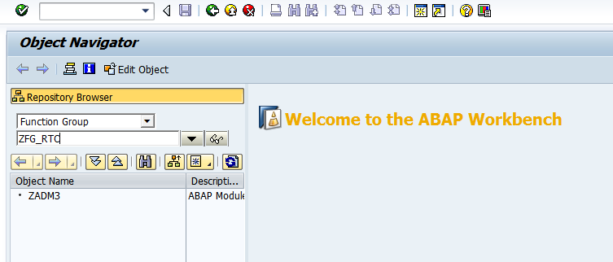

1. A pop asking if ‘Function group needs to be created’ pops up. Click on yes.

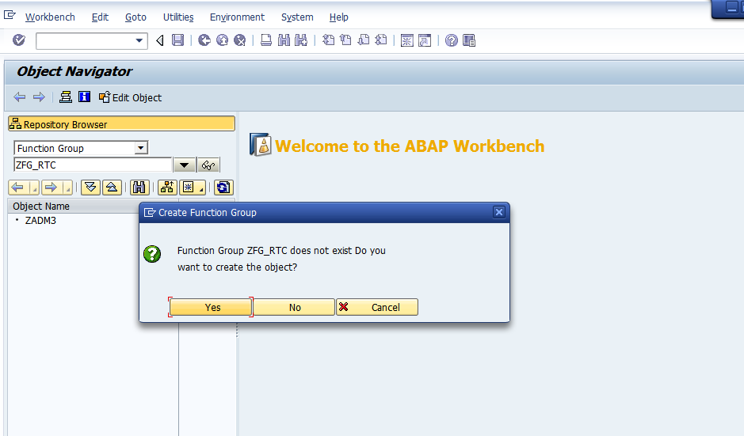

1. Give any short description and save it in a local package.

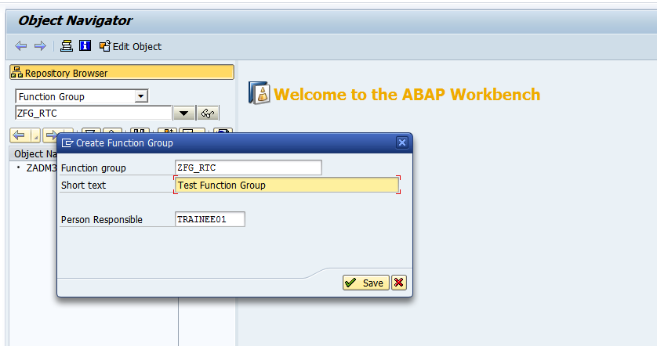

6. You will get a green message at the bottom saying ‘Function group is created’

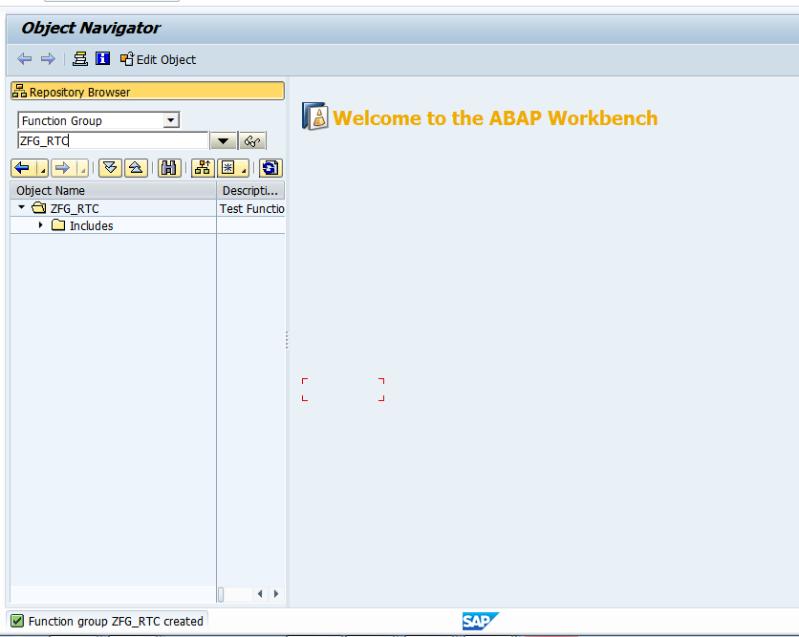

7. Right click on the name of the function group as shown. Choose to activate.

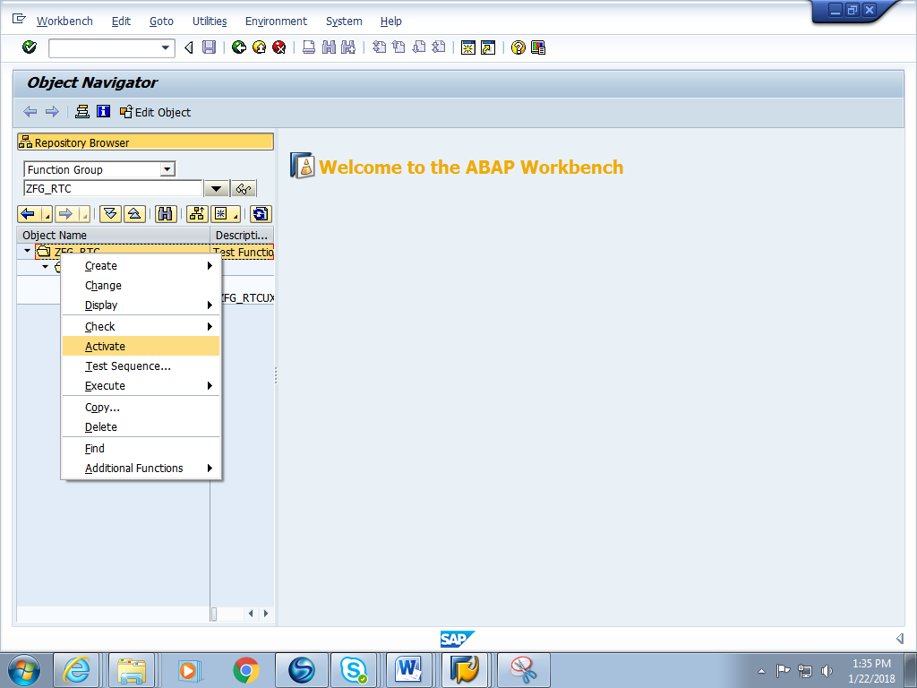

8. The function group is activated and ready for use.

